1. Define Asset Categories

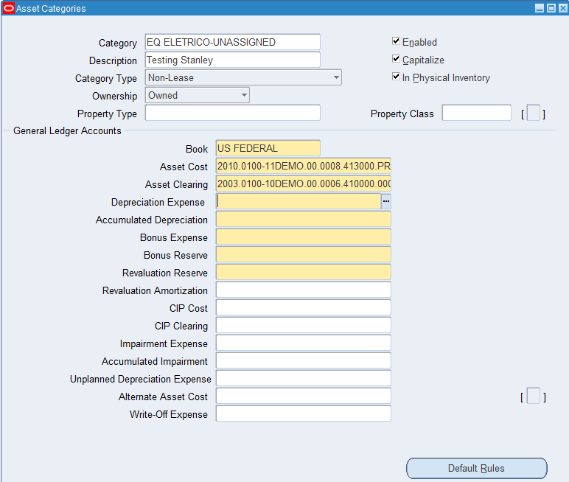

2. Define Locations

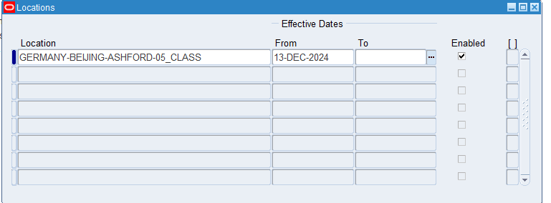

Add an Asset:

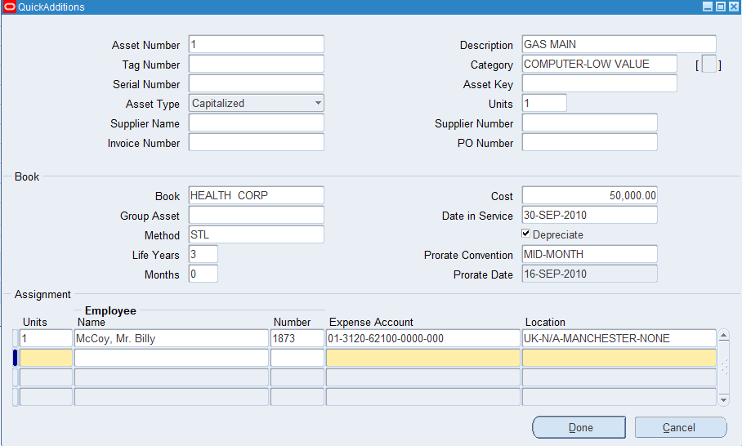

Save

4. Assign asset to the user

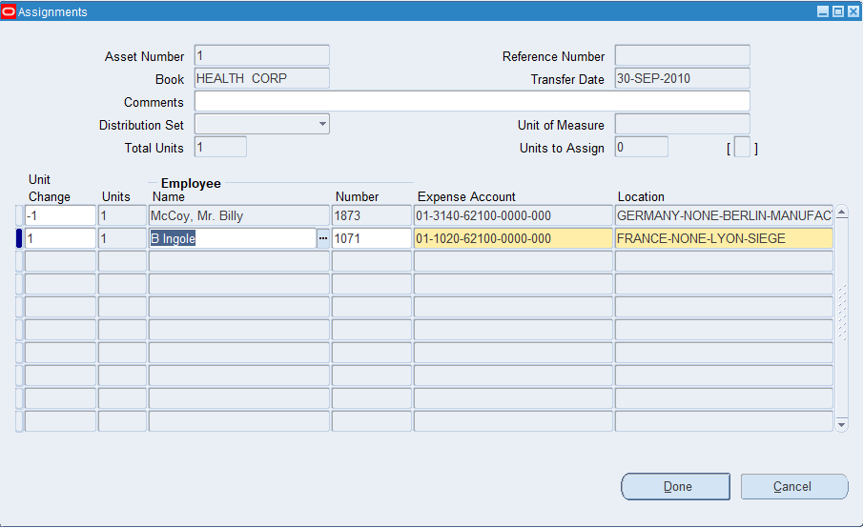

5. Verify one of the Asset Details [Asset Book: US FEDERAL]

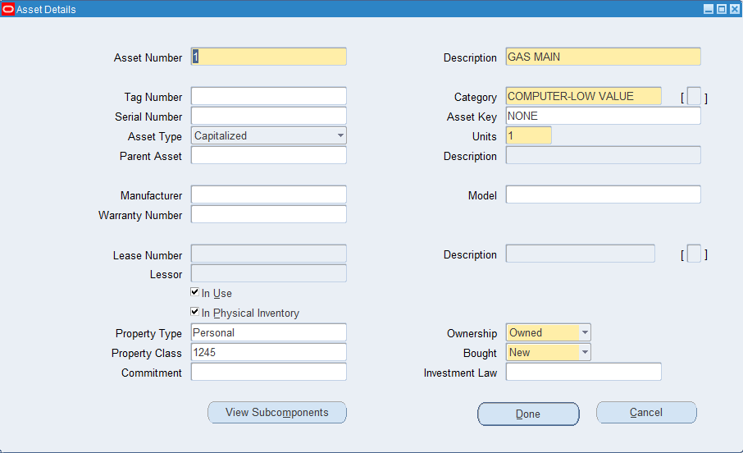

6.

12 Assets [US-Federal]

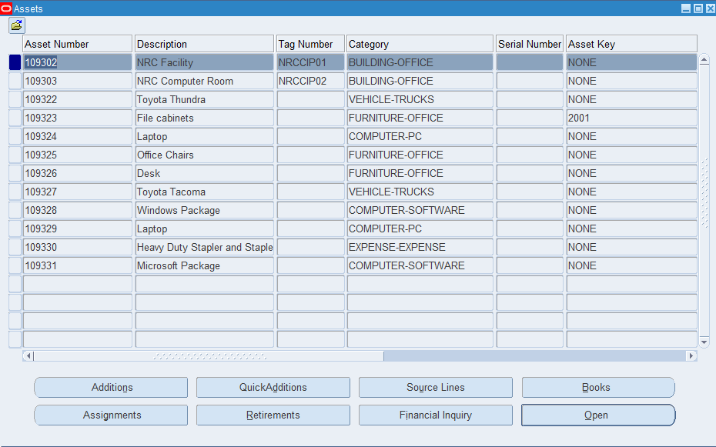

8. FA KFF

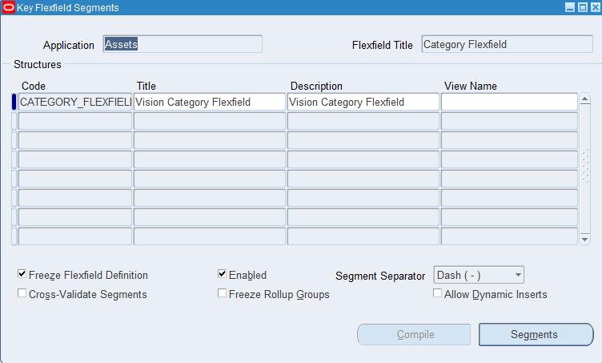

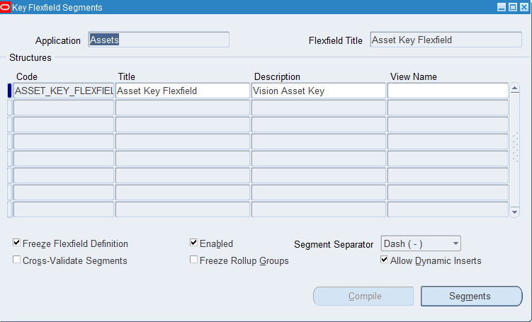

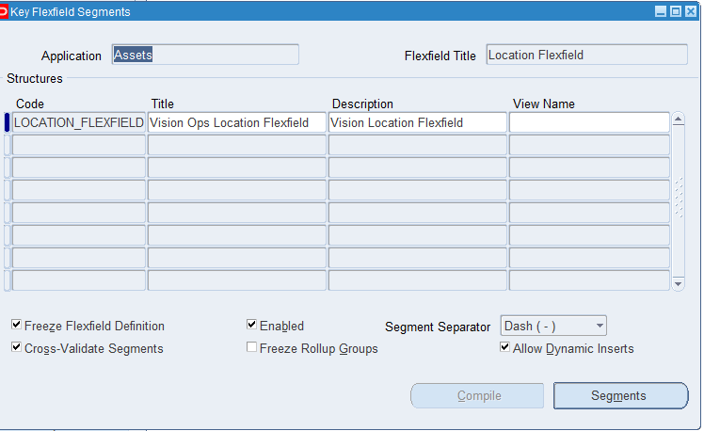

9. Depreciation Calendar and prorate calendar

Navigation: Setup -> Asset System -> Book Controls -> Query for the book

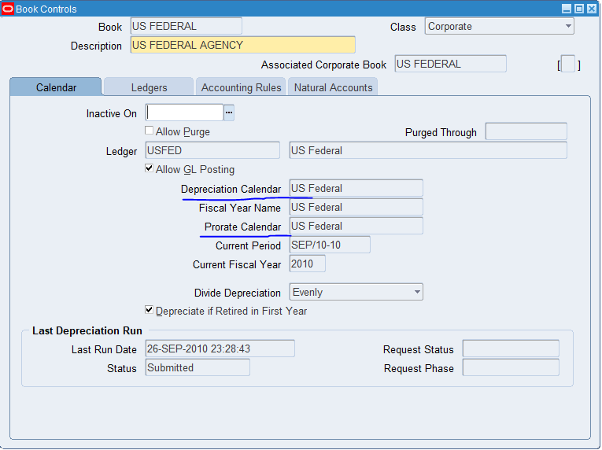

10. What is last Depreciation Run for the Asset Book: US Federal & what is the status?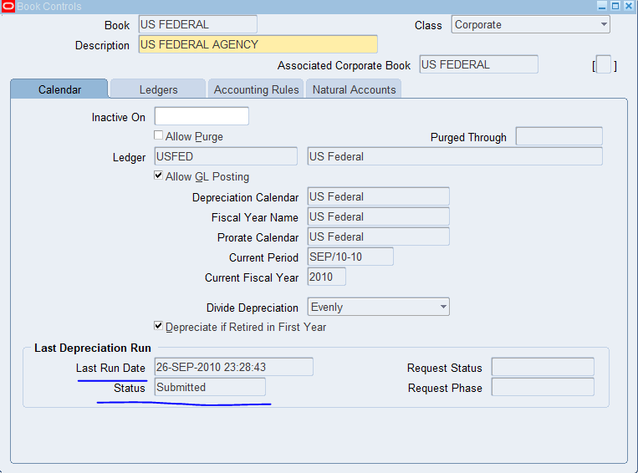

11. What Ledger is associated with US FEDERAL asset book

Setup>Asset System > Book Controls> US FEDERAL > Ledgers

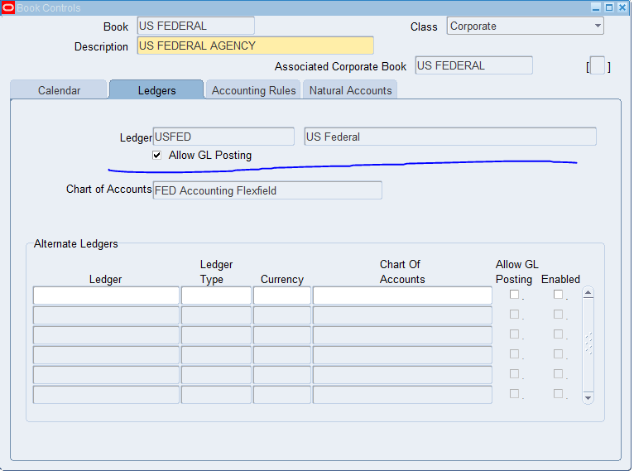

12. What is the Chart of Accounts for US FEDERAL Asset Book: FED Accounting Flexfield

Setup>Asset System > Book Controls> US FEDERAL > Ledgers

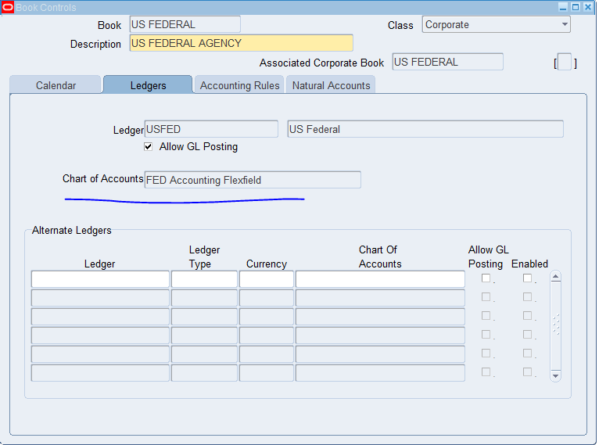

13. System Control Details for VISION ENTERPRISES

Setup > Asset System > System Controls

